Project Design Phase
Solution Architecture
Date | 28 September 2026
Team ID | SWTID-2026-9038
Project Name | Script-Controlled ACL – Restrict Record Access Based on Field Value
Maximum Marks | 4 Marks

Team Leader: K. Kumutha | Members: R. Siva Dharshini, S. Vayshavi, M. Jasmin
Solution Architecture:
Solution architecture is a complex process – with many sub-processes – that bridges the gap between business problems and technology solutions. Its goals are to:
- Find the best tech solution to solve existing business problems.
- Describe the structure, characteristics, behavior, and other aspects of the software to project stakeholders.
- Define features, development phases, and solution requirements.
- Provide specifications according to which the solution is defined, managed, and delivered.

Example - Solution Architecture Diagram:
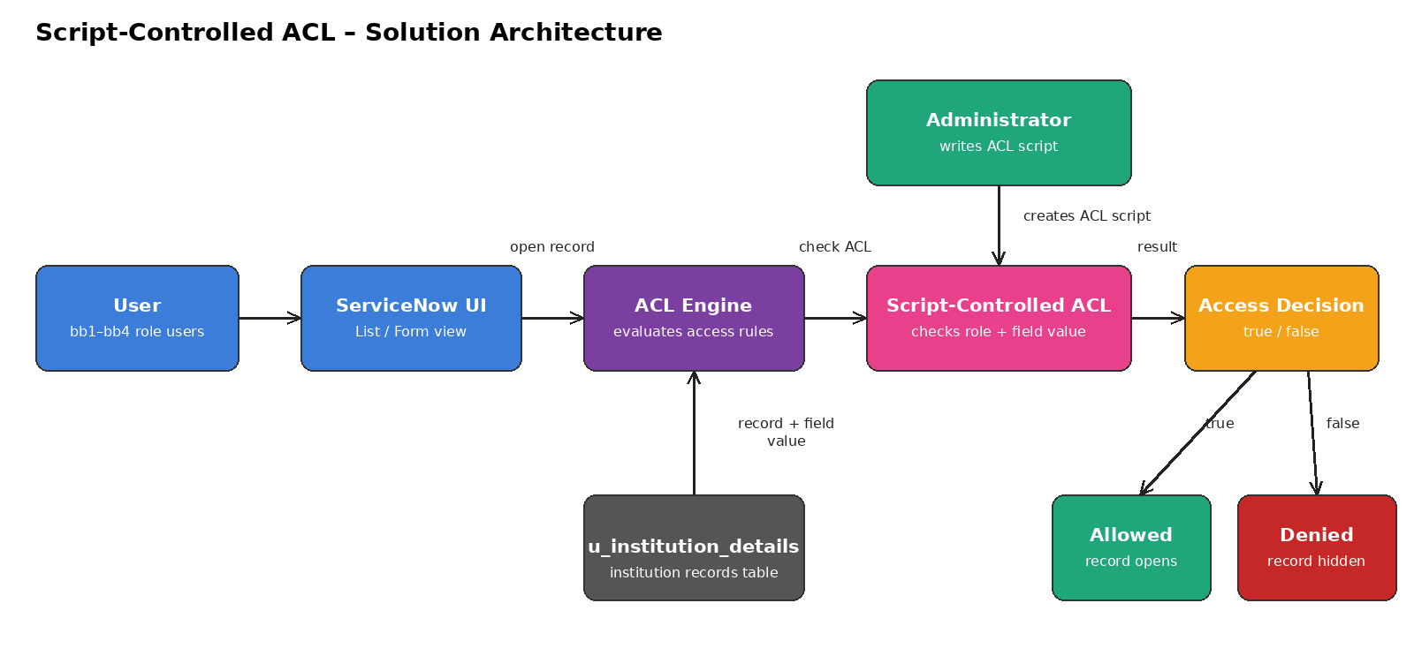
Figure 1: Architecture and data flow of the Script-Controlled ACL solution
The administrator writes a script-controlled ACL for the institution details table. When a bb1–bb4 user opens a record, the ACL engine runs the script, which checks the user's role and the record's field value and returns true (record opens) or false (access denied).
Reference: ServiceNow product documentation – Access Control rules (docs.servicenow.com)

